COSC-1436, Lab Assignment 1

Answer the following questions:

1. What is Windows 10? (5 points)

A. The tenth version of the Windows game program.

B. An example of Open Source Software.

C. Normally only installed on Servers.

D. An example of an Operating System.

2. What happens when the power switch is turned off on your computer? (5 points)

A. the contents of main memory are lost.

B. the contents of your hard drive are lost.

factory option settings are restored.

D. factory option settings are lost.

3. What is the decimal equivalent of the binary number 10101? (5 points)

A. 16

B. 20

C. 21

D. 42

4. What is a good definition of a computer programming variable? (5 points)

A. Output from a computer program.

B. A piece of digital information.

C. Four eight-bit bytes.

D. A named storage location in memory.

5. What is the binary equivalent of the decimal number 57? (5 points)

A. 111001

B. 101010

C. 111010

D. 101101

6. What is the difference between a compiler and an interpreter? (5 points)

The difference is that the compiler converts the code of the algorithmic language into an executable code, while the interpreter independently recognizes and executes line-by-line instructions of the program code.

7. Use the Internet to find out which five (5) programming languages are most widely used today. Cite a reference for your answer. (5 points)

Java, C, Python, C++, C#.

PutanoBen, Ben. “The 5 Most Popular Programming Languages of 2019.” Stackify, 2 Oct. 2019, stackify.com/popular-programming-languages-2018/.

8. You will use an IDE to compose, compile, and execute your programs. What does IDE stand for? What is the name of the IDE that we will use in this course? (5 points)

Microsoft Visual Studio *Community* 2017.

9. When is your first Programming Project Due? (5 points)

The November 24.

10. What is the ASCII code for the pound sign (**#**)? Express your answer as a complete sentence. (5 points)

To answer this question I use ASCII table:  
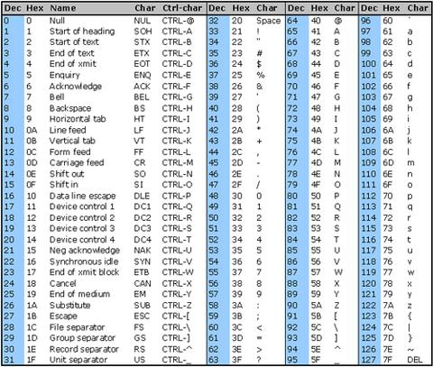

When I look throw this table I notice that code for the pound sign (#) have decimal value(35) or hexadecimal number 0x23.

Inside Week 1 within our Blackboard course, Click on the link in the Lab Assignment 1 Folder and watch “**How Computers Work: Hardware and Software**” (5:23). Express your answers to the following questions in your own words using complete sentences.

11 List three examples of computer hardware that were identified by Erica, who works at Amazon.com. (10 points)

The examples of computer hardware are wires, chips, speakers and plugs.

12. How did Jerome, who works at Team Xbox, basically describe his job? (10 points)

He basically bringing the hardware and the software together to give you all the games that you love on your Xbox.

13. How did Jerome describe the Central Processing Unit (CPU)? (10 points)

Jerome said that CPU is the master chip that controls all the other parts of the computer. CPU inside has smaller, simpler parts that handle specific tasks. It has circuits to do simple math and logic. CPU has other circuits to send and receive information to and from different parts of the computer.

14. What is the most basic form of software according to Jerome? (10 points)

Binary code is the most basic form of software.

15. How did Bill Gates of Microsoft describe the Operating System? (10 points)

Operating system of the computer is the master program that manages how software gets to use the hardware of the computer. Also he said that operating system is a program with special abilities that let it control the other software on the computer. It let you install the programs by loading them into your computer’s memory.